Budget 2021 – International development

International development overview
International development spending has been cut by $144.4 million from last year to a total of $4,435.3 billion, just a tenth of the budget allocated to Defence. The budget papers estimate that $1.3 billion of this funding goes to supporting gender equality across the program, however when considered as a proportion of total ODA this figure places us in 22nd place out of 29 OECD donors. There are some welcome initiatives, particularly the allocation of $170 million regional funding over five years to Pacific Women Lead. With the Generation Equality Forum – an international platform for accelerating action on gender equality – just weeks away, Australia needs to extend this regional commitment to the global level to ensure that we are taking a strong stand against backlash on women’s rights and gender equality.

International Development

The Budget
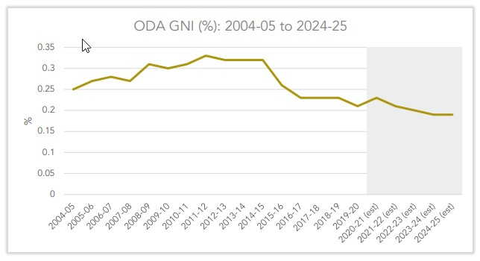
Australia’s international budget this year will be $4,435.3 billion, a cut of $144.4 million against last year’s reported total. DFAT’s Development Budget Summary reports this in a convoluted fashion, claiming the total figure for international development as $4 billion, with an additional $435.3 million in “temporary, targeted and supplementary measures to respond to COVID-19.” This arbitrary categorisation of core v temporary ODA was introduced in last year as a political maneuver to keep the government's political commitment to limit aid spending at $4bn until the FY2022-23, when it is scheduled to grow with inflation, while still recognising that the scale of the issues in the region require an Australian aid spend greater than $4bn.
Source: ACFID, 2021, 2021-2022 Federal Budget facts and figures, pp 6

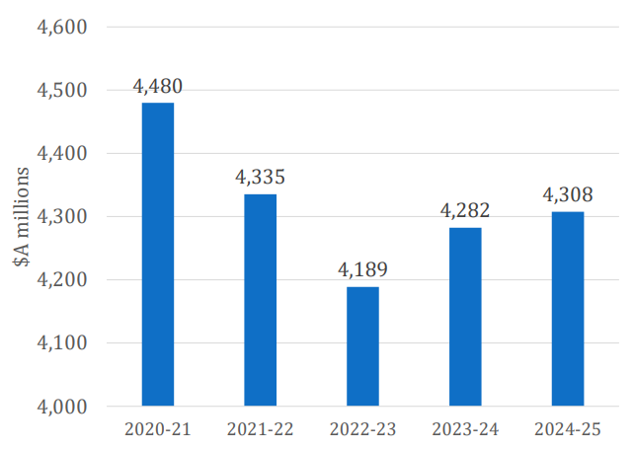
Australia’s international development budget continues to backslide against the global target for developed nations to allocate 0.7 per cent of Gross National Income (GNI) to Official Development Assistance (ODA), now sitting at 0.21 per cent of GNI (down from an estimated 0.22 per cent in FY2020-21). International development spending as a proportion of all government spending now sits at 0.74 per cent (or 74 cents in every $100), and the overall international development budget remains around one tenth of the budget allocated to Defence. The $335.3m allocated to COVID-19 prevention and recovery in the Asia Pacific region includes funding for economic support for the Pacific and Timor Leste ($100m), vaccine access for the Pacific and Southeast Asia ($162.6m), COVID-19 response and recovery in India ($16.7m) and programs to strengthen partnerships across Southeast Asia ($56m). Forward estimates for ODA predict that the international development budget will begin to increase with inflation, beginning from the lower figure of $4 billion, meaning that even by FY2024-25 official Australian ODA still will be lower than it is this year.
Source: DevPol, 2021, The 2021 Aid Budget, pp 6

The Pacific continues to receive the highest funding allocation of all regions, remaining at $1.44bn with an additional $174.8m in temporary and targeted COVID-19 response funding, including $74.8m for vaccine access and $100m for economic support. ODA funding for Fiji has jumped significantly – a 23.8 per cent increase to $81.2m, but funding to Papua New Guinea (PNG) and the Solomon Islands has decreased. (However, these figures do not include the new temporary COVID-19 response funding, making it difficult to understand whether a cut has been implemented this year.) There has been a small increase in funding to Southeast and East Asia, which reflects increased funding to Myanmar. Funding to South and West Asia increased ($273.1m up from $193.4m in FY2020-21), although this does not go anywhere close to reversing the 60 per cent cut to the region that was made in the FY2020-21 budget.

Transparency around the international development budget was significantly reduced in 2020, with the documentation provided by DFAT going from a 120-page publication to a 4-page summary. It was not restored this year, although the 4-page summary now includes a welcome breakdown of COVID-19 spending. Concerningly, reporting on performance and aid effectiveness has also been diminished under the Department’s Partnerships for Development policy and no information has yet been released against this framework. In particular, the government has abandoned as an official target the commitment that 80 per cent of international development programming must effectively address gender issues, a flagship commitment established by former Foreign Minister Julie Bishop. The new framework separates the release of performance data from budget information, undermining the ability of civil society to contextualise budget commitments against past performance.

Gender implications

Why is this an issue for women?
The 2021-22 Federal Budget comes at a critical moment for COVID-19 response, recovery and reset in the Indo Pacific region and beyond. The surge of COVID-19 cases in Papua New Guinea and India in early 2021 have shone a spotlight on the impacts of the pandemic on underfunded health systems and there are deep concerns that health systems in each country are close to collapse. Women have been disproportionately impacted by the Covid-19 pandemic which has exacerbated existing social, economic and health inequalities between men and women and amongst diverse women. In the Pacific, extremely high rates of gender-based violence have increased since the start of the pandemic, which is consistent with reports from other countries. Across Asia and the Pacific, women perform four times more unpaid care work than men, and the closure of paid care-providing facilities and schools will only increase this workload, further impacting women’s ability to engage in paid work.
Beyond COVID-19, there are other significant and emergent challenges which pose direct threats to women’s rights. In Myanmar, women human rights defenders have been the forefront of resistance against the military coup, which took place in February on the same day MPs were due to be sworn in following the November 2020 election. 724 people have been killed and 3,878 people have been detained by the military, who are targeting peaceful protestors, opposition MPs, journalists and human rights defenders including founder of Women’s League of Burma and Mizzima news Thin Thing Aung. There is a well-documented history of the Tatmadaw using sexual violence as a weapon of war, particularly against ethnic minorities, and women’s rights groups have received reports of sexual assault against those women protestors who have been detained.
Finally, this federal budget is critical because it comes just six weeks before Australia will be called to stand up at the Generation Equality Forum in June and make transformative commitments to accelerate implementation of the 1995 Beijing Platform for Action, the most ambitious global commitment on gender equality to date. Without additional resourcing across both international and domestic portfolios, Australia will not be able to stand alongside our international peers and be seen to be progressing gender equality, both for women in Australia and those around the world.

What are the 2021 Budget impacts on women?

There are some welcome initiatives for women’s rights and gender equality in the budget. The government has allocated $170m over five years to fund Pacific Women Lead – the new program that will replace Pacific Women Shaping Pacific Development (the 10 year, $320m program that has been running since 2012). This allocation is understood to apply to the regional components of the program (such as multi-country initiatives, research and movement building), with country-based initiatives understood to be additional to this figure.

The new program includes sectoral focus areas which were not included in the previous program – particularly women’s health and sexual and reproductive health and rights – making direct comparison of the funding envelope difficult.

However, women’s rights organisations have welcomed the announcement, while calling for additional detail on how bilateral programs will be incentivised to continue allocating funding to critical gender equality initiatives, and for a commitment to allocate 20 per cent of the program towards feminist movement strengthening and research.

Funding for climate change partnerships has increased from $20m in FY2020-21, to $40m in FY2021-22. This is part of a government commitment to spend $1.5b on climate change assistance through the international development program to 2025, however significant future announcements will be needed in order to meet this commitment. The Pacific region has experienced significant loss and damage to communities and livelihoods arising from climate change. The 2018 Boe Declaration on Regional Security, signed by Australia alongside other Pacific Island Forum States, identified climate change as “the single greatest threat to the livelihoods, security and wellbeing of the peoples of the Pacific.” Women and girls face disproportionate climate risks as a result of discriminatory gender norms and structures, that undermine their access to livelihoods, and their safety and security. In the lead up to the Glasgow Climate Summit in November 2021 (COP 26) and the next Commission on the Status of Women (CSW) meeting in 2022, there is a need for further funding announcements that recognize the intersections of gender equality and climate change and seek to address the gendered impacts of climate change for women in our region.

However, any cut to the international development budget diminishes Australia’s ability to support gender equality and women’s rights in our region. This budget represents a cut of $144.4 million against last year’s estimated total ODA, and forward estimates for ODA predict that the international development budget will fall by approximately $200m in FY2022-23, before it is scheduled to be indexed to inflation. Any decrease in future years to funding to our region will undermine our response and recovery from the longer-term impacts of the COVID-19 pandemic, and the ongoing challenges to gender equality and women’s rights.

The budget papers claim an estimated $1.3 billion of Australia’s international development budget goes towards gender equality, however, closer examination calls the merit of this claim into question. The figure is based on the proportion of Australia’s ODA which is classified as having a principle or significant focus on gender equality against the OECD DAC Gender Marker. According to the most recent data reported by the OECD, Australia stands at 5 per cent principle and 36 per cent significant, a total of 41 per cent or $1.3 billion overall.

While $1.3 billion may sound impressive, 41 per cent puts us in the bottom third of the pack, ranking at just 22 out of 29 countries. Canada leads at 92 per cent, coming close to meeting their target of 95 per cent. This is all the more impressive because it is a harder bar to clear than the 80 per cent target previously set by Australia, which was never linked to the OECD DAC maker and instead based on internal aid quality assessments. This demonstrates the difference between Canada, a country which has committed to a feminist international assistance program where gender equality is a central objective, and Australia, which has prioritised gender equality but not to the same extent.

Significant shifts in political will at the highest level will be needed to drive the change required within DFAT if Australia is to regain its place amongst the global leaders on gender equality in development.
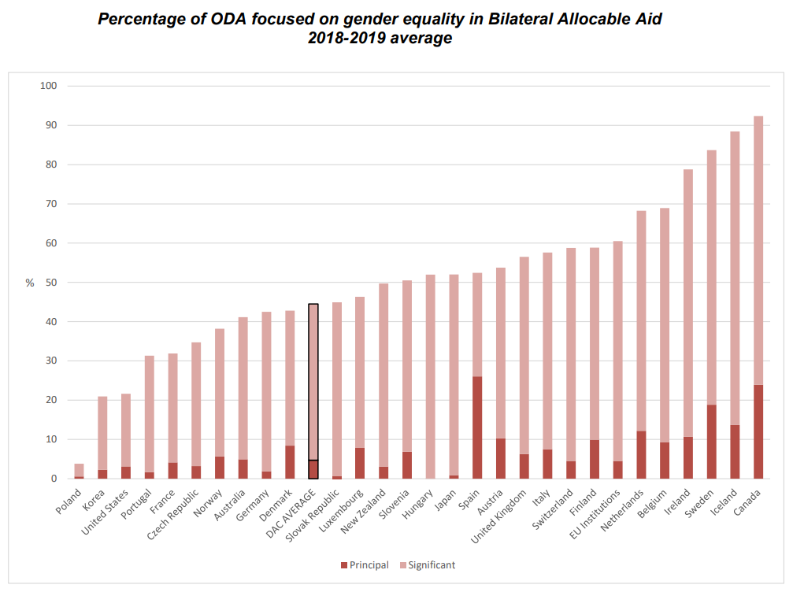
Little information has been provided in the budget to indicate how Australia is supporting civil society groups and women human rights defenders in Myanmar who are leading resistance to the military coup and advocacy toward the establishment of a fully democratic system. The budget papers included $325,000 in funding for military cooperation, although this has now been clarified as an error and will be removed, given that Australia suspended all military cooperation with the Tatmadaw earlier this year. Apart from this significant oversight, DFAT have been criticised by diaspora, academia and civil society groups for failing to implement sanctions on military officials, an approach which is out of step with other likeminded nations. The release of the long overdue National Action Plan on Women Peace and Security in April 2021 is welcome, however the plan decentralises+ budget and implementation to the participating departments, and no information has been provided on how activities under the plan will be resourced. The evidence is clear that inclusion and leadership of women in peace processes is essential to their longevity, and the situation in Myanmar poses a clear test for Australia on this agenda.
Source: OECD, 2021, Aid in Support of Gender Equality and Women’s Empowerment, pp 4; annotation added

Core funding to gender and disability remain unchanged from last year, with the Gender Equality Fund at $65m and core funding to disability at $9.6m. Disappointingly, the 25 per cent cut to the Central Disability Fund from last year’s budget has not been restored and disability spending through country and regional programs remains unclear, a decision which could undermine progress for diverse women and girls in our region. Women with disabilities are uniquely disadvantaged by gender inequality and disability discrimination and face systemic barriers to equality and inclusion. They are also 2 – 3 times more likely to experience violence than women without disabilities, including in countries in the Asia Pacific. More information is needed to support further analysis of core budget allocations to gender, disability and social inclusion, and how these can be used to address the needs of diverse women in our region. Without sustained increases in funding to support gender mainstreaming and disability inclusion it will be difficult for the international development program to take an intersectional approach and ensure that the needs of diverse women and girls with disabilities are met.

Recommendations
That the Australian Government:
- Commit to ongoing and increased funding for the international development budget, including gender equality programming, to lay the foundation for COVID-19 response, recovery, and reset.
- Resource gender, disability, and social inclusion by reversing the 25 per cent funding cut to the central disability fund and significantly increasing the proportion of ODA targeting gender equality, including through increases in funding to women’s rights organisations.
- Allocate 20 per cent of funding within Pacific Women Lead to feminist movement strengthening and research, and ensure bilateral programs are incentivized to fund work under the program.
- Increase the predictability, transparency and flexibility of ODA by reintroducing multi-year budgeting and allowing funds to be rolled-over between financial years.
- Increase the staffing portfolio of DFAT in Canberra and at Post with a focus on development and gender expertise.

This represents 45 per cent of bilateral allocable aid, ie: ODA which is eligible for assessment against the OECD DAC marker, which is a subset of the total ODA budget.

