Budget 2021 – Social services

Income support overview
Women are over-represented in reduced employment outcomes, levels of poverty, and reliance on income support payments. During the COVID-19 pandemic the Government’s Coronavirus Supplement and other short-term supports lifted women, who were 54 per cent of recipients, and children out of poverty.

Women were disproportionately impacted by the COVID-19 crisis, through job losses and extra care responsibilities. These effects are likely to have long-term negative consequences.

The New Employment Services Model (NESM) was intended to use online services for job-ready unemployed in order to free up funding for help to the most vulnerable, including long term unemployed. It was also intended to reduce caseloads for managers. However, the budget papers do not indicate that funding for will deliver outcomes for people seeking employment, rather it raises concerns that vulnerable customers will struggle with the online platforms. It is also not clear that the savings will go towards more support.

Also concerning is the mutual obligation Targeted Compliance Framework (TCF), which is attached to many income support payments, including jobactive and ParentsNext, has received increased funding. The TCF disproportionately effects women and is punitive, controlling, and ineffective at supporting people into employment. The TCF needs to be revisited.
The increase to the base rate of working-age payments by $50 per fortnight from 1 April 2021 fails to lift social security payments above the poverty line and is completely inadequate. Proper indexing of cost-of-living increases would assist in keeping Australians out of poverty (see Indexing paper).

Income Support

The Budget

New Employment Services Model
Payments ($m)
 | 2020-21 | 2021-22 | 2022-23 | 2023-24 | 2024-25
Services Australia | - | 32.3 | 3.6 | 1.1 | 1.1
Department of Social Services | - | -8.3 | -126.3 | -140.3 | -140.3
Department of Education, Skills and Employment | -1.8 | 15.1 | -232.2 | 135.3 | 107.8
Total — Payments | -1.8 | 39.2 | -354.9 | -3.8 | -31.3
Source: 2021 Budget Paper No 2, p. 92.
The Government will introduce a new approach to employment services that is digitally driven, tailored and flexible. The New Employment Services Model (NESM) will ensure job seekers move into sustainable work, employers’ needs are met, and employment services providers’ efforts are focused on those job seekers who need help most. The NESM will introduce two pathways of support for job seekers – Digital Services and Enhanced Services. Digitally capable job seekers will be able to self-manage finding employment through Digital Services for 12 months (after which they will transition to Enhanced Services). Job seekers not in Digital Services will receive tailored and intensive case management support from Enhanced Services providers. Funding for this package includes $699.4 million over five years from 2020 21 to expand and strengthen specialist services to support job seekers.

Cashless Debit Card — Jobs Fund and Income Management extension
Payments ($m)
 | 2020-21 | 2021-22 | 2022-23 | 2023-24 | 2024-25
Administrative Appeals Tribunal | - | nfp | nfp | - | -
Services Australia | - | nfp | nfp | nfp | nfp
Department of Health | - | nfp | nfp | nfp | nfp
Department of Social Services | - | nfp | nfp | nfp | nfp
Total — Payments | - | - | - | - | -
Source: 2021 Budget Paper No 2, p. 179.
The Government will provide funding to support the continuation of the Cashless Debit Card (CDC) on an ongoing basis.

Enhancing Welfare Integrity Arrangements
Payments ($m)
 | 2020-21 | 2021-22 | 2022-23 | 2023-24 | 2024-25
Services Australia | 0.7 | 8.8 | 7.2 | -2.7 | -2.7
Office of the Director of Public Prosecutions | - | 2.0 | 2.0 | - | -
Department of Social Services | - | -5.0 | -5.2 | -1.5 | -0.4
Total — Payments | 0.7 | 5.8 | 4.0 | -4.2 | -3.1
Source: 2021 Budget Paper No 2, p. 180.
The Government will provide an additional $27.6 million over five years from 2020-21 to extend Taskforce Integrity and cease third party verification of parents claiming Parenting Payment and JobSeeker Payment.

Increased support for unemployed Australians
Payments ($m)
 | 2020-21 | 2021-22 | 2022-23 | 2023-24 | 2024-25
Department of Social Services | 675.5 | 2,510.8 | 2,157.4 | 2,107.5 | 2,109.3
Services Australia | 14.1 | 10.3 | 11.2 | 10.1 | 9.8
Department of Education, Skills and Employment | 4.4 | 130.0 | 74.8 | 41.1 | 33.4
Department of Agriculture, Water and the Environment | 2.7 | 10.5 | 8.3 | 5.6 | 8.1
Department of Veterans' Affairs | 0.4 | 2.3 | 2.0 | 2.1 | 2.3
Department of Health | 0.3 | 2.7 | 4.2 | 5.7 | 7.0
Total — Payments | 697.4 | 2,666.7 | 2,257.9 | 2,172.2 | 2,169.9
Related receipts ($m)
Australian Taxation Office | - | 45.0 | 165.0 | 145.0 | 145.0
Source: 2021 Budget Paper No 2, p. 181.
The Government will provide $9.5 billion over five years from 2020-21 to increase support for people eligible for working age payments including JobSeeker Payment, further strengthen mutual obligation requirements and maximise job seekers’ ability to find and retain employment.

Gender implications

Why is this an issue for women?
Women are struggling to secure their financial security in the Australian economy, due primarily to the gendered nature of unpaid work, such as childcare or housework, but also through the high numbers of women experiencing gender-based violence and the disproportionate number of women who head single-parent households.
Women are more likely to live in households below the poverty line than men (14.1% compared to 13.1% for men). The majority of individuals in poverty (including children) are women or girls (52.9%).
Women work fewer hours than men and account for 67.2 per cent of part-time workers in Australia. Women (9.3 per cent) consider themselves to be underemployed more than men (6.6 percent), and 16 per cent more women (58 per cent) than men (42 per cent) are not in the labour force at all. Women fill 54 per cent of all casual jobs. Since the post-COVID recovery in employment began, women’s jobs are becoming even more insecure: casual jobs account for over 60 per cent of new jobs, and women fill 62 per cent of those casual roles. Despite having higher educational attainment than men, women are underrepresented in the labour market. Women’s economic participation rate (61.8 per cent) is still significantly worse than men’s (70.9 per cent).
Unsurprisingly, women in Australia are also more likely to be reliant on income support when compared to men. According to June 2020 data, when consolidating all Centrelink payment types women make up 57% of recipients.
Historically there has been a close relationship between unemployment levels and unemployment benefits. However, changes to the payment in recent decades has changed the profile of recipients. Thus, the demographics of JobSeeker recipients have substantially changed over time, with women and men now making up almost equal shares of JobSeeker recipients. For example, in the 1990s and early 2000s, JobSeeker recipients were usually young men in their 20s or 30s. Older men and women were also represented in the pool of welfare recipients, however, those requiring income support were likely receiving other payments such as parenting payment, age pension, or disability support pension (DSP). The makeup of recipients by gender and age group has changed considerably. Now JobSeeker payment recipients are predominantly people in their 40s or above, with an increasing share of older women.
While there have been significant changes to Australia’s economy over this time, and the population is ageing, policy changes have also impacted the demographics of JobSeeker recipients as illustrated by this graph:
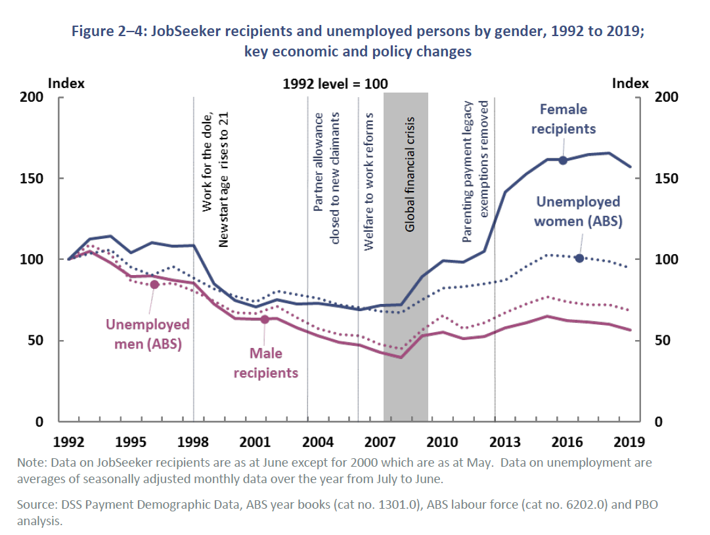

Single parent families, 82 per cent of whom are female-headed, remain the family type with the greatest experience of poverty. With the transfer of thousands of single parents to the Newstart Allowance annually since 2007, poverty has risen for sole parent families from 47 per cent to 66 per cent between 2009 and 2014.

What are the 2021 Budget impacts on women?

Overall, the social security and income support measures in the budget are inadequate. Expanding training and local jobs programs for those who are unemployed is welcome; however, this does not account for the 1.3 million people on JobSeeker and Youth Allowance payments. The focus on personal tax cuts ($20 billion) benefit those already in paid employment and leave those in poverty further behind. There has been no additional spending for those in poverty or those on low incomes—who we know are overwhelmingly women. The $671 million cut for newly arrived migrants, and the $200 million cut to employment services are also a cause for concern. Women are the majority of Commonwealth Rent Assistance (CRA) recipients. CRA has been inadequate for many years. Sole parents and older women on Jobseeker are much more likely to be renting. Together with no investment in social housing, the budget offers no relief to their housing plight.

New Employment Services Model
The new approach to employment services that is digitally driven has implications for compliance and reporting obligations that arise out of individuals who do not have resources to access online services. Digital inclusion is a complex and multi-dimensional issue involving technological, social and economic factors. Women have an Australian Digital Inclusion Index (ADII) score 1.9 points below that of men in Australia, with similar differences across Access and Affordability (2.1 and 3.0 points) and a slightly narrower gap in relation to Digital Ability (0.5 points). Women have a lower level of digital inclusion than men across all age categories, however, it is widest in the 65+ age bracket (3.0 points).
Savings from the introduction of the NESM, and removal of backdating, plus increased funding for the mutual obligation TCF regime, seems to result in a net negative investment in assistance to the unemployed. These measures cannot just be about cost cutting it must ensure outcomes for clients.

Cashless Debit Card — Jobs Fund and Income Management extension
Whilst investment in a Jobs Fund in cashless debit sites is welcome, it should not be contingent on being subjected to the discriminatory and ineffective cashless debit card.
The Cashless Debit Card does not benefit women. It has disproportionately targeted First Nations women. NFWA rejects any assertion that the CDC is a financial literacy tool, and there is limited empirical evidence that it improves the wellbeing of individuals or communities, either by reducing substance abuse or by increasing employment outcomes. Additionally, there is no evidence that the CDC reduces other associated social harms, such as domestic and family violence. On the contrary, there is evidence to suggest that increased rates of domestic and family violence coincide with the CDC. The CDC also carries a high risk of unintended and expensive consequences across government and the community, including social exclusion and stigmatisation, increased financial hardship, and the erosion of individual autonomy and dignity. The proposal to extend the CDC scheme will further exacerbate the negative impacts of the scheme, and the selected regions for the expansion will continue to disproportionately target First Nations peoples, as the proposed areas have high Indigenous populations: this is discriminatory and undermines self-determination. The CDC scheme is a punitive and paternalistic measure incompatible with both human and consumer rights. Ultimately, it is driven by ideology rather than sound evidence.

Enhancing Welfare Integrity Arrangements
Abolishing Third Party Verification (TPV) that applies to single parents claiming JobSeeker or Parenting Payment, which discriminates against single parents, is a welcome decision. It is concerning savings from the measure will be partly redirected to debt recovery.
The extension of operation “Taskforce Integrity” must not be used to demonise and scare women from getting much needed income support, as has been seen in the past.

Increased support for unemployed Australians
This budget failed to lift social security payments above the poverty line. JobSeeker Payments and related income support remain at $44 a day.
In response to the COVID-19 crisis the Government provided a $550 per fortnight supplement to recipients of the Jobseeker Payment, Parenting Payment, Youth Allowance, Farm Household Allowance, Special Benefit, Partner Allowance, Widow Allowance and student payments between April 2020 – March 2021.
Around 54 per cent of Coronavirus Supplement recipients were women. While there are fewer women than men receiving JobSeeker Payment and Youth Allowance (other), more women than men receive other income support payments, such as Parenting Payment and Youth Allowance (student and apprentice). 15 per cent of women reported receiving the supplement compared to 11 per cent of men. Analyses conducted by ANU researchers demonstrated the impact the changes had on poverty in Australia. Despite the economic downturn, poverty rates in Australia decreased by 33 per cent due to the COVID-19 supplement. For those already on either Newstart/Jobseeker or the Youth Allowance, the poverty rate dropped a dramatic 90 per cent when compared to pre-pandemic rates to June data.
Temporary payment increases had a dramatic impact on many vulnerable populations. People reported improved mental health at a time when the general population was experiencing worsening mental health; they also engaged in more job-seeking behaviours, improved physical health and greater capacity to look after children. Single mothers reported that these changes, while in effect, reduced their anxiety as their financial security increased and allowed them to pay household bills; increased their health and nutrition as they could afford proper food purchases; and even improved sleep due to the reduction in money stress; many also reported being able to have critical dental work done.
Many mutual obligation requirements, including intensive reporting, jobseeking and meetings were temporarily suspended. The Government’s study into Understanding economic and policy trends affecting Commonwealth expenditure noted that people remain on unemployment payments longer than they used to because people who are not job-ready are being pushed off of more appropriate payments and onto JobSeeker. Creating stress and anxiety through the TFC and mutual obligation requirements may be an intentional strategy for encouraging people off of income support. However, research does not support this outcome. Rather, chronic psychological stress saps cognitive resources and makes it more difficult to plan and execute long-term goals. The Federal Inquiry into jobactive agreed with this assessment: “The committee is of the view that the new TCF arrangements are unnecessarily burdensome and prioritise a punitive compliance approach over meaningful employment outcomes.”
The expansion of the eligibility criteria for JobSeeker Payment and Youth Allowance (other) for those required to self-isolate or care for others as a result of COVID-19 for a further three months to 30 June 2021, is welcome but may need to be extended to respond to the evolving nature of the pandemic.

Recommendations

NFAW joins ACOSS in calling for a permanent increase to the rate of JobSeeker and related income support payments to at least $65 a day. This increase must not come at the expense of other vital supports provided, including to people who have children, people renting privately, people fleeing violence, or people with an illness or disability. For women who have unique constraints and barriers to entering the workforce, lifting them above the poverty line will continue to mitigate the rate of poverty and its effects, including on children, in Australia.

The TFC and mutual obligation requirements should be amended to ensure that breaches do not result in a payment suspension. Additionally, obligations should not be onerous, as creating stress reduces capacity for productivity.

End compulsory income management and the implementation of the Cashless Debit Card (CDC) scheme (pursuant to the Social Security (Administration) Amendment (Income Management to Cashless Debit Card Transition) Bill 2019 (Cth)) across all current sites, abandon any further expansion, and re-invest in local community services and initiatives.

