Budget 2020 – Social Services: Income support

Income Support Overview
Women were already over-represented in reduced employment outcomes, levels of poverty, and reliance on income support payments prior to the COVID-19 pandemic and its attendant effects on the Australian economy. The recession and the overwhelming focus on male-dominated industries for stimulus support means Australia is facing a ‘she-cession.’
The Coronavirus supplements and other short-term supports provided by the Government lifted women and children out of poverty. They should be retained, particularly as we enter a recession. Proper indexing of cost of living increases would also assist in keeping Australians out of poverty.
The Targeted Compliance Framework (TCF), which is attached to many income support payments, jobactive, and ParentsNext, is punitive, controlling, and ineffective at supporting people into employment. The TCF needs to be revisited.

Income support

The Budget
The Government will provide $16.8 billion over five years from 2019-20 to new and existing income support recipients during the COVID-19 pandemic.
Since 27 April 2020, the Government established a new time-limited Coronavirus Supplement to be paid at a non-income tested rate of $550 per fortnight. This is paid to both existing and new recipients of JobSeeker Payment, Youth Allowance, Parenting Payment, Austudy, ABSTUDY Living Allowance, Farm Household Allowance, Special Benefit, and recipients of the Department of Veterans’ Affairs Education Schemes, Military Rehabilitation and Compensation Act Education and Training Scheme and Veterans’ Children’s Education Scheme.
From 25 September 2020 this supplement will change to $250 per fortnight and continue to 31 December 2020. The income free area will change to $300 per fortnight with a 60 cents taper for income earned above the income free area for JobSeeker Payment (except principal carer parents who have an income free area of $106 and a taper rate of 40 cents) and Youth Allowance (other) recipients.

Payment eligibility has been relaxed on a temporary basis, with the One Week Ordinary Waiting Period being waived from 12 March 2020, and a range of further exemptions, including waiving the Newly Arrived Residents’ Waiting Period, Assets Test, Liquid Assets Waiting Period and Seasonal Work Preclusion Period, have been applied from 25 March 2020. Eligibility criteria for JobSeeker and Youth Allowance (Other) has also been extended to allow sole traders and the self-employed to access the payments provided they meet income test requirements. From 25 September 2020 the Assets test and Liquid Assets Waiting Period will be reinstated with all other eligibility waivers continuing to 31 December 2020.
Mutual obligation requirements were temporarily lifted on 24 March 2020 and then gradually reinstated from 9 June 2020 in line with the gradual removal of COVID-19 restrictions. Mutual obligations will be changed to give job seekers greater flexibility to count education and training toward their activity requirements.
This measure forms part of the Government’s economic response to COVID-19. (Source: 2020 Budget Paper 2, pp. 270-271.) For the entire income support budget, please see 2020 Social Services Portfolio, Budget-Related Paper No. 1.12, pp. 33 – 47.
COVID-19 Response Package — income support for individuals
Payment ($m) 2019-20 |  | 2020-21 | 2021-22 | 2022-23 | 2023-24
Department of Social Services | 5,873.7 | 11,869.9 | 0.2 | - | -
Services Australia | 31.5 | 109.6 | 2.1 | 0.7 | 0.8
Department of Agriculture, Water and the Environment | 18.1 | 47.7 | - | - | -
Department of Education, Skills and Employment | 14.5 | 150.2 | 63.3 | 32.9 | 21.6
Department of Veterans' Affairs | 2.9 | 5.8 | - | - | -
Department of Health | 1.6 | 1.3 | - | - | -
Total — Payment | 5,942.3 | 12,184.5 | 65.6 | 33.6 | 22.4
Related receipts ($m)
Australian Taxation Office | - | 600.0 | 900.0 | - | -
Related capital ($m)
Department of Education, Skills and Employment | 2.1 | 0.4 | - | - | -
Department of Veterans' Affairs | 0.3 | 0.3 | - | - | -
Total — Capital | 2.3 | 0.8 | - | - | -
Source: 2020 Budget Paper 2, p. 270.

Gender implications

Why is this an issue for women?
Women are more likely to live in poverty than men, with 20% of all women living in poverty compared to 17% of men (OECD, 2019). Women also spend more years living in poverty compared to men (The Melbourne Institute, 2017, p.36).
The gender pay gap remains entrenched at 14% (WGEA, 2020). Economic modelling indicates that many of the gains the gender pay gap in recent years actually reflect that pay is getting worse for men rather than improving for women, and this is more likely to happen during times of economic contraction such as we are now experiencing (Cassells, 2017). Furthermore, the gender pay gap is modelled off of full-time wages; when part-time employment is considered, the gender pay gap more than doubles (Dawson, 2020). The gender pay gap also persistently reflects a premium paid in male-dominated industries compared to female-dominated (WGEA, 2019).
Some of this is due to gendered expectations for women, including being the primary carer of children (WGEA, 2018; Kleven, Landais & Søgaard, 2018), which compromises employment opportunities in myriad ways. Women are also much more likely to provide other unpaid caring support (ABS, 2019), and this gender disparity has increased since the onset of COVID-19 (AIFS, 2020). Despite having higher educational attainment than men (WGEA, 2019), women are more likely to be working part-time, below their capacity, and in precarious employment (Maury, 2017).
Unsurprisingly, women in Australia are also more likely to be reliant on income support when compared to men. According to June 2020 data, when consolidating all Centrelink payment types women make up 57% of recipients (AIHW, 2020). However, when looking specifically at the Jobseeker allowance, their numbers are 14% below those of their male counterparts.
While women are less likely than men to be on the Jobseeker (then Newstart) payment, their numbers have skyrocketed for all age groups below retirement age, effectively doubling the number of women on either Jobseeker or the Youth Allowance. Figure 1 provides a comparison of women on the Newstart Allowance and the Youth Allowance at August 2019 (pre-pandemic); and on Jobseeker and the Youth Allowance at April 2020 (approximately one month into the pandemic response), and August 2020 (the most recent data set available). Women aged between 45-65 are the most likely to be on Jobseeker, with women aged 34-44 least likely. The numbers show a marked increase between April and August of this year for all age groups.
Figure 1: Changes in income support for women by age, pre- and post-COVID-19
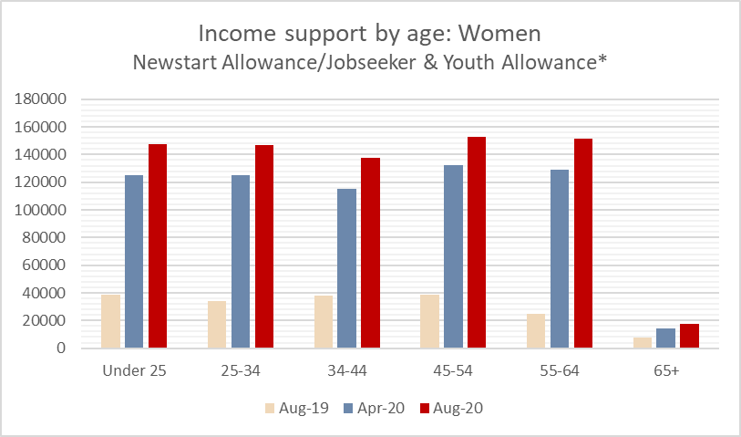
* The age brackets used to report data has changed since August 2019; the numbers in this column are therefore approximate but not exact.
Single parent families, 83% of whom are female-headed, remain the family type with the greatest experience of poverty (ABS, 2019). With the transfer of thousands of single parents to the Newstart Allowance annually since 2007, poverty has risen for sole parent families from 47% to 66% between 2009 and 2014 (ACOSS and UNSW, 2020, p. 28 footnote 21). Furthermore, while child support payments are often factored into single-parent families’ income calculations by Centrelink, it can also be very difficult for mothers to collect (Natalier and Edwards, 2019). While adequate child support payments that are received on time can alleviate poverty (Skinner, Cook and Sinclair, 2017) and assist single mothers to return to the workforce (Fisher, 2017), Australia’s system places the onus on women to collect payments from non-compliant former partners, which means it is commonplace to have late or missed payments (Goodall & Cook, 2019).
And yet mothers are highly motivated to do all they can to create an economically secure future for themselves and their children. The Department of Social Services reports that women who are reliant on Newstart are much more likely to have earned income compared to men – 21% compared to 12.5%. Of this group, women are much more likely to be earning ‘significant’ income ($254+ per fortnight); 16.2% of women compared to 9% of men (Department of Social Services, 2019).

What are the 2020 Budget impacts on women?
In March 2020, the Government provided a $550 per fortnight supplement to recipients of the Jobseeker Payment, Parenting Payment, Youth Allowance, Farm Household Allowance, Special Benefit, Partner Allowance, Widow Allowance and student payments. This was reduced by 50% on 25 September, and will be eliminated completely on 31 December (Klapdor, 2020). Fifteen per cent of women reported receiving the supplement compared to 11% of men in a recent ABS household survey (ABS, 2020). Additionally, many mutual obligation requirements, including intensive reporting, jobseeking and meetings were temporarily suspended.
Analyses conducted by ANU researchers (Phillips, Gray & Biddle, 2020) demonstrate the impact that these changes have had on poverty in Australia. Despite the current economic downturn, poverty rates in Australia have decreased by 33% due to the COVID-19 supplement, while without the supplements poverty was projected to double. For those already on either Newstart/Jobseeker or the Youth Allowance, the poverty rate has dropped a dramatic 90% when compared to pre-pandemic rates to June data. Without the supplement, poverty for this group would have risen. Projections are that the September and December reductions will see a commensurate rise in poverty rates for people on these payments.
Figure 2 below shows the poverty line (dotted black line), and the dramatic but short-term change in poverty rates for those receiving the supplement on Jobseeker (Bradbury and Whiteford, 2020). Note also that the Pension rate (blue line) is keeping just at or slightly below the poverty line.

Figure 2: Income support payments in relation to the poverty line
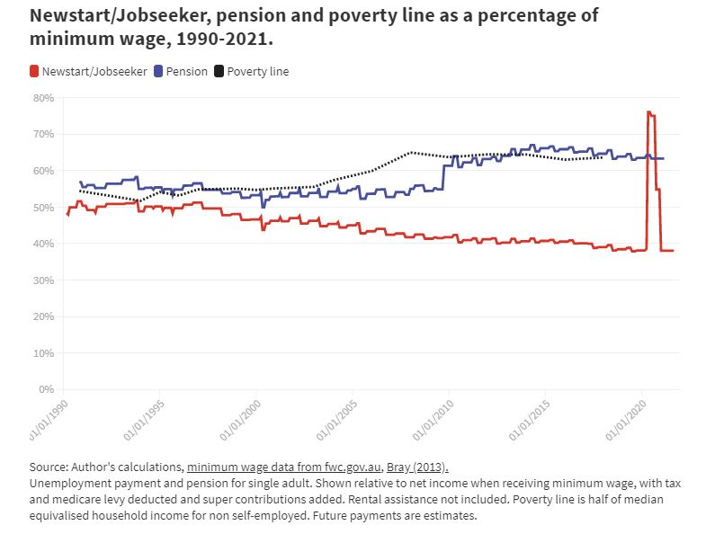
Temporary payment increases have had a dramatic impact on many vulnerable populations. Single mothers reported that these changes, while in effect, reduced their anxiety as their financial security increased and allowed them to pay household bills; increased their health and nutrition as they could afford proper food purchases; and even improved sleep due to the reduction in money stress; many also reported being able to have critical dental work done (Edwards, 2020).
The proposed return to the grossly inadequate Newstart payment levels in December will be even more harsh during a recession, when the competition for jobs is even greater, thus condemning the most disadvantaged to crushing poverty and lessening the impact their spending would have on stimulating the economy (Deloitte, 2020). NFAW is pleased the treasurer has flagged the government’s willingness to look at what a permanent change to the level of payments.
Creating stress and anxiety through the TFC and mutual obligation requirements may be an intentional strategy for encouraging people off of income support. However, research does not support this outcome. Rather, chronic psychological stress saps cognitive resources and makes it more difficult to plan and execute long-term goals (Maury, 2019). The Federal Inquiry into jobactive agreed with this assessment: “The committee is of the view that the new TCF arrangements are unnecessarily burdensome and prioritise a punitive compliance approach over meaningful employment outcomes” (Parliament of Australia, 2019, paragraph 8.22).

Recommendations

- NFAW recommends that the $550 per fortnight supplement remain in place, at least for women who are not in a position to seek permanent, full-time employment. For women who have unique constraints and barriers to entering the workforce, lifting them above the poverty line will continue to mitigate the rate of poverty and its effects, including on children, in Australia.

- The TFC and mutual obligation requirements should be amended to ensure that breaches do not result in a payment suspension. Additionally, obligations should not be onerous, as creating stress reduces capacity for productivity.

